 Kings Wood Owners’ Corp.
_____________________________________________________________________________________________________________________
146 Church Street, Apt. 3B (631) 269-6424 Phone
Kings Park, New York 11754 (631) 269-3945 Fax Email: kingswoodowners@aol.com

SUBLEASE Application Instructions

Apt. #_____________ Contact Phone #_______________________ Date: _____________

Applicant Name(s): ____________________________________________________________

The attached Sublease Application Form must be completed before the Subleasing of any unit at Kings Wood Owners Corp is considered for approval. Be assured that all of your personal information is held strictly confidential.

APPLICATION CONTENTS
- Application for Occupancy (credit application per person)
- Additional Information
- House Rules Acknowledgement
NOTE: No Smoking Rule and Rent Claim due to default
- Employment Confirmation Authorization
- Vehicle Registration
- Resident Emergency Contact Information
- Protect Your Family From Lead in Your Home

WHAT YOU NEED TO SUBMIT
Please forward the following information and fees (Money order or Bank Check made payable to “Kings Wood Owners' Corp.”) to the Property Manager’s attention (Helena Chaves) at the address above.
- Completed Application
- Copy of pay stubs for past one month
- Copy of renters insurance declaration page showing Kings Wood Owners Corp. as an additional insured (see attached requirements).
- A Bank Check or Money Order in the amount of $575 for one person or $725 for two people (Note: this includes a $425 Application Processing fee and a $150 fee per person to run credit/criminal background check. If you are rejected $250 will be refunded.
- Subtenant’s Move-in/Move-out Fee ($700)
- Photo ID
- Previous landlord reference letter
- An executed copy of new proposed Sublease Agreement (between Shareholder and Subtenant – supplied by
Kings Wood)
- Letter from shareholder’s mortgage lender authorizing the sublet of the apartment. ADMISSIONS APPLICATION FORM sublease.doc (Revised 12/16/2024

KWOC SUBLEASE Application Instructions Continued

Apt # _______________ Applicant(s) Name______________________________________

After received and appropriate references are verified by this office, it will be submitted to the Admissions Committee for review. The prospective sub-lessee(s) will then be notified of the Committee’s decision after meeting with the Admissions Committee.

All approvals will be subject to inspection of the apartment, correction of any violations, and payment of an inspection fee of $150. Please be advised that under no circumstances may the prospective sub-lessee(s) move into said apartment until the Board grants final approval of the sub-lease.

THE PROCESS
Once the completed Application is received, a date will be set to meet with the Admissions Committee who will make a recommendation to the Board. If approved by the Board of Directors an inspection of the apartment must be completed prior to closing.

NOTICE
You may access information on Fair Housing and Anti-Discrimination laws by visiting the websites below or by contacting the agencies listed below:

FEDERAL:
New York Regional Office (Housing and Urban Development)
26 Federal Plaza, Suite 3541
New York, NY 10278-0068 Phone:
212-264-8000 website: www.hud.gov/offices/fhco/fhlaws/index.cfm

NEW YORK STATE:
New York State Division of Human Rights (Suffolk)
State Office Building
250 Veterans Memorial Highway, Suite 2B -49 Hauppauge, NY 11788 Phone:
631-952-6434 email: infolongisland@dhr.state.ny.us

New York State Division of Human Rights (Nassau) 175 Fulton Ave., Suite 404 Hempstead, NY 11550 Phone:
516-538-1360 email: infolongisland@dhr.state.ny.us website:
www.dhr.state.ny.us

THIS PROPOSAL SHALL RESULT IN NO LEGAL OBLIGATION UNTIL A FORMAL SUBLEASE IS EXECUTED BY THE PARTIES CONCERNED AND BOARD APPROVAL IS GRANTED.

In applying for consent to this proposed sublease, the undersigned acknowledges that consent is required by the terms of the Proprietary Lease. The undersigned also understand that they will be required to meet with the Admissions Committee of the Board of Directors prior to the approval.

_______________________________________ _______________________________________
Applicant Co-Applicant

KWOC SUBLEASE Application Additional Information Date:____________________

Applicant ______________________________________________________________________
(first name) (last name) (date of birth)
Co-Applicant ______________________________________________________________________
(first name) (last name) (date of birth)
Current Shareholder: __________________________ Property Address ________________________

SUBLEASE $____________________ PER MONTH

Date of Possession (approximate)____________________

CURRENT LANDLORD________________________________________________________________

Your Current Job: Company name: ____________________________ Location (City); ____________

Title: ____________________________ Start Date: ___________ End Date: ____________

Yearly Salary (Net) $__________________ Monthly Income (Net) $_____________

Please give any additional information which may be pertinent or helpful as an indication of the nature of your occupancy.
___________________________________________________________________________________

____________________________________________________________________________________

List names and ages of ALL persons who will live in apartment: ________________________________

_____________________________________________________________________________________

List all clubs, and memberships: __________________________________________________________

_____________________________________________________________________________________

List Schools and Colleges attended by applicant: _____________________________________________

_____________________________________________________________________________________

Have you ever been convicted of a crime? ___Yes ___No

If yes, describe: _______________________________________________________________________

Why would you like to live at Kings Wood __________________________________________________

Initial this page: _________

KWOC SUBLEASE Application Additional Information Applicant(s):______________________________

Where are you living now? (Address) ________________________________________Years_______

if Landlord Name______________________________Phone___________________________________

List your residence addresses for the past 10 years:
_____________________________________________Phone_______________________Years_______

_____________________________________________Phone_______________________Years_______

_____________________________________________Phone_______________________Years_______

_____________________________________________Phone_______________________Years_______

_____________________________________________Phone_______________________Years_______

Provide three references not related to you:

- Name:____________________________________________ Relationship: _________________

Address___________________________________________ Phone: ______________________

- Name:____________________________________________ Relationship: _________________

Address___________________________________________ Phone: ______________________

- Name:____________________________________________ Relationship: _________________

Address___________________________________________ Phone: ______________________

Initial this page: _________

KWOC SUBLEASE Application Additional Information
Applicant(s):_____________________________

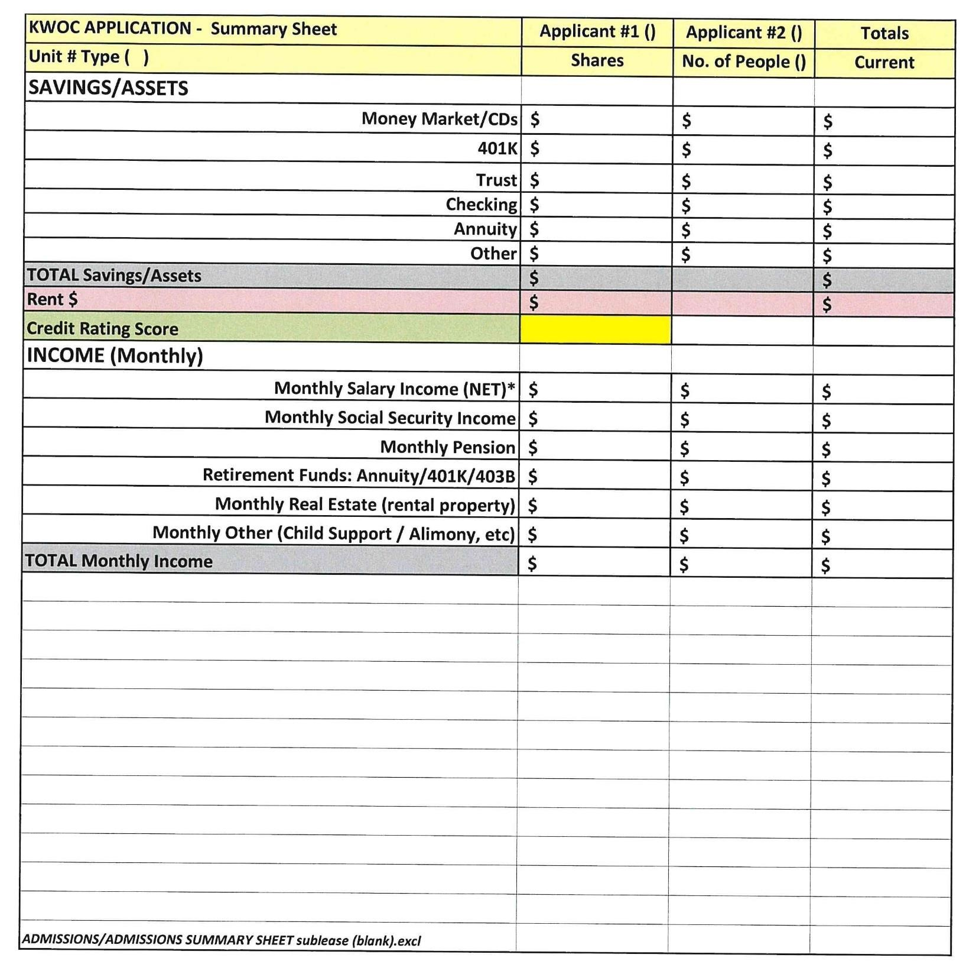

KWOC Purchase/Refinance Application Additional Information Applicant(s):______________________________
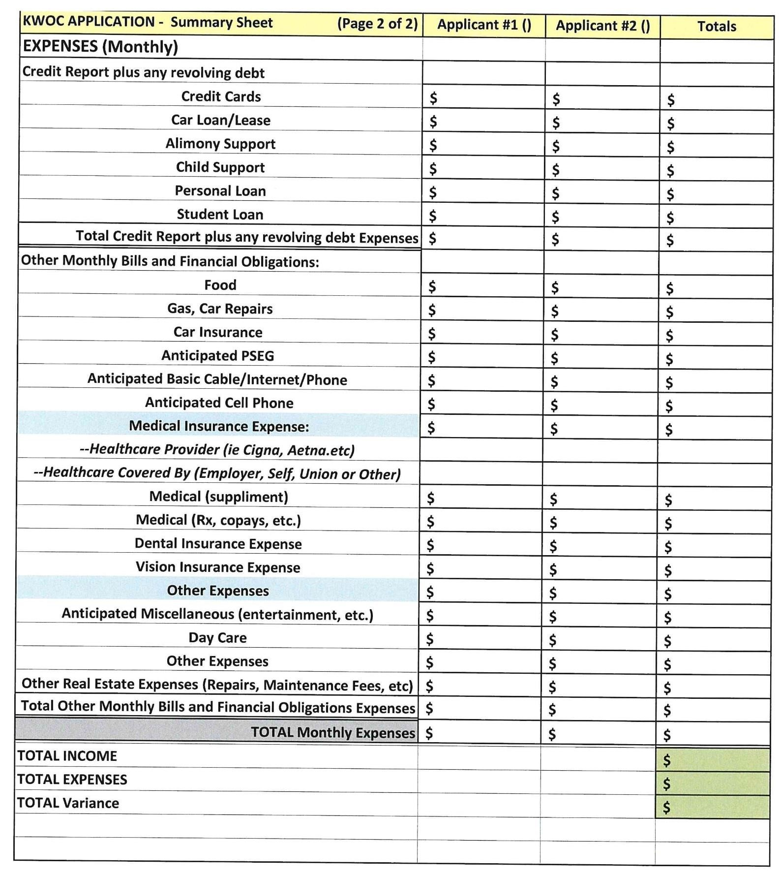

*If Applicant has other real estate holdings, include maintenance costs (oil, electric, insurance, water, etc) on separate sheet and add total to monthly expenses above.

KWOC SUBLEASE Application Applicant(s):______________________________

HOUSE RULES ACKNOWLEDGMENT

This will confirm that I have read and understand the Kings Wood Owners’ Corp. House Rules and Regulations. As written in section 5.18 of the House Rules, it is required that new residents must comply with the following specifications.

5.18 Flooring Specifications Amended June 1, 2019:

All Shareholders:
Unless expressly authorized by the Board of Directors in each case, the floors of each Apartment must be covered with rugs or carpeting or equally effective noise-reducing material, to the extent of at least eighty (80%) percent of the floor area of each room with the exception of kitchens, bathrooms, closets and the foyer.

Current & New Shareholders:
Shareholders wishing to modify their existing floor covering must obtain approval from the Board of Directors.

Request forms are available in the Property Office or on our website kingswoodowners.com. Follow the Guidelines attached to the request form along with your details of the proposed material. This must be complete prior to installation.

FAILING TO OBTAIN PRIOR WRITTEN APPROVAL WILL RESULT IN A VIOLATION FEE

When replacing your carpet and padding, your floor boards should be checked for squeaks. Squeaky board(s) should be screwed into the joist to eliminate squeaking noise(s) prior to installing new carpet, padding and laminate. Please contact the Kings Wood office to schedule this work at NO COST to the shareholder.

Please sign below to confirm that you have received the House Rules and acknowledge the floor covering requirements and understand that there are fines and charges that may be incurred for non-compliance of House Rules. Please submit a signed copy to the Property Office and retain a copy for yourself.

I/We the undersigned have received and read a copy of the Kings Wood House Rules and Regulations and agree to abide by all the rules and regulations contained therein.

THIS PROPOSAL SHALL RESULT IN NO LEGAL OBLIGATION UNTIL A FORMAL PURCHASE IS EXECUTED BY THE PARTIES CONCERNED AND BOARD APPROVAL IS GRANTED.

You are hereby authorized to submit to the Cooperative Apartment Corporation this proposal together with the above information concerning the undersigned. In applying for consent to this proposed purchase, the undersigned acknowledges that consent is required by the terms of the Proprietary Lease. The undersigned also understand that they will be required to meet with the Admissions Committee prior to the approval by the Board of Directors to discuss your expectations, the Kings Wood community, its House Rules and procedures. Any information, advice or promises regarding repairs, occupancy, rules, responsibilities, etc. made by a 3rd party (ie. Realtor or Seller) and not included in the Kings Wood Bylaws, Proprietary Lease, and/or House Rules is not binding on Kings Wood Owners Corp. Applicant(s) should read the House Rules prior to coming to the Admissions Committee meeting and be prepared with any questions or concerns that they have regarding the House Rules.

_______________________________________ ______________________________________
Applicant Print & Signature Date Co-Applicant Print & Signature Date

Kings Wood Owners’ Corp.
____________________________________________________________________________________________________________________
146 Church Street, Apt. 3B (631) 269-6424
Kings Park, New York 11754 (631) 269-3945 Fax email: kingswoodowners@aol.com

SUBLEASE Application
EMPLOYMENT AUTHORIZATION

TO: _____________________________________
(Company Name)

ATTN: __________________________________ Title ________________________
(first name, last name)

I ________________________________, hereby authorize you to release to Kings Wood Owners’ Corp. the following information:

Date:_________________ Signature ________________________________
(employee)
State of New York
County of Suffolk

Sworn to Before Me This _____ Day of ________________, 20__

__________________________
Notary

- My hire date: ______________________________

- My position: ______________________________

- My current yearly salary: ____________________

Date:_________________ Signature ________________________________
(employer)

Instructions: Please have your employer complete this form and ask them to fax it to Kings Wood.

KWOC Purchase/Refinance Application Additional Information

Applicant(s):______________________________

NOTICE ABOUT TENANT SCREENING
REPORTS

Tenant screening reports from consumer reporting agencies are sometimes used to assist landlord in making purchase/sublease decisions. We may use such reports by contacting ApplicantSafe/TenantSafe Phone:
732-942-1331

Tenant screening application “Application for
Occupancy” on following page…

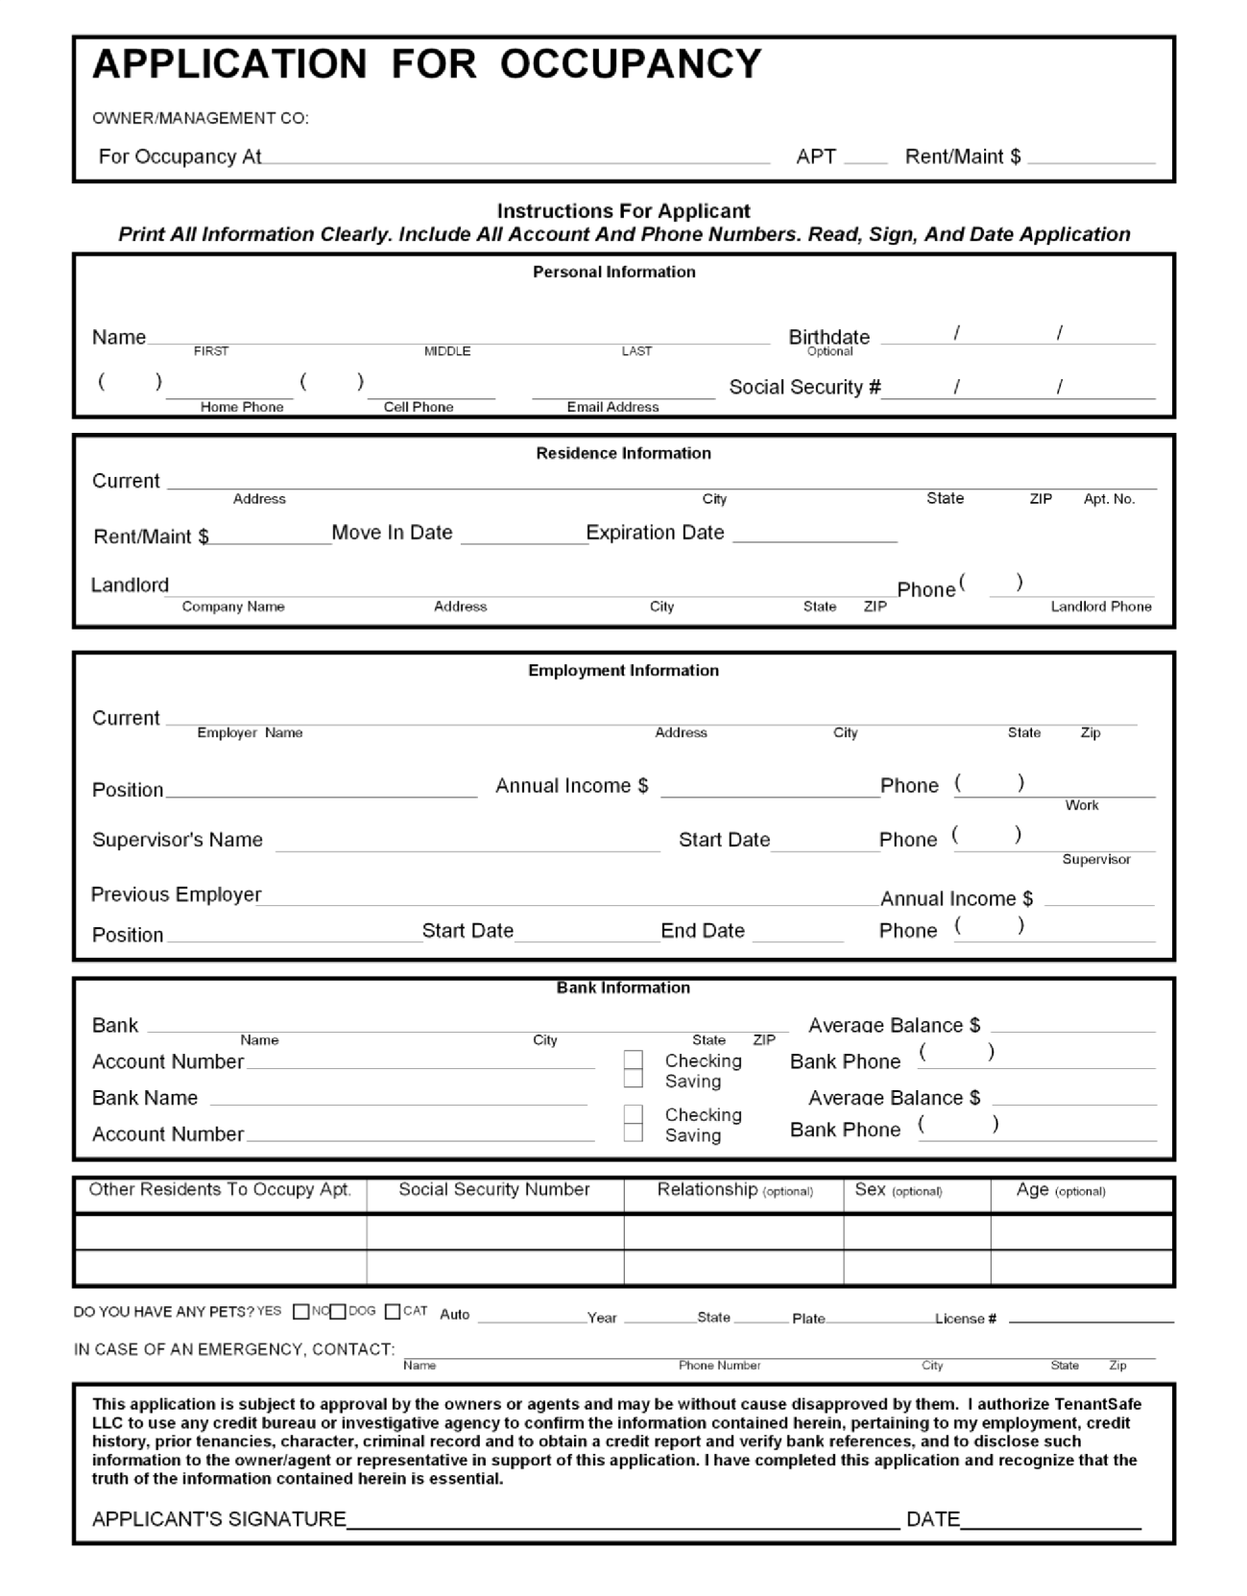
I hereby authorize Kings Wood Owners' Corp. to release my credit profile to the landlord for which I am requesting apartment occupancy, the Corp's. Board of Directors, its Admissions Committee, Attorney, Accountant and Property Manager.

Applicant’s Signature: _________________________________________________ Date: _____________________

Kings Wood Owners’ Corp.
____________________________________________________________________________________________________________________
146 Church Street, Apt. 3B (631) 269-6424
Kings Park, New York 11754 (631) 269-3945 Fax email: kingswoodowners@aol.com

VEHICLE REGISTRATION FORM

Please complete the Vehicle Registration Form below and return it to the Property Manager at 146-3B Church Street, Kings Park, with copies of the following information to receive a KWOC parking sticker. All residents’ vehicles must be registered and have a parking sticker affixed to the window. Please Print Clearly

- Copy of Drivers License
- Registration & Insurance Declaration Page

Resident Name: __________________________________________________

Shareholder’s Name: __________________________________________________

Unit #_________ Assigned Reserved Spot #_________________

Make:____________________ Model_________________ Year: _________

Color_____________________ License Plate #__________________________

Resident Name: ___________________________________________________

Shareholder’s Name: ___________________________________________________

Unit #_________ Assigned Reserved Spot #__________________

Make:____________________ Model_________________ Year: _________

Color____________________ License Plate #___________________________
Kings Wood Owners’ Corp.
____________________________________________________________________________________________________________________
146 Church Street, Apt. 3B (631) 269-6424
Kings Park, New York 11754 (631) 269-3945 Fax email: kingswoodowners@aol.com

RESIDENT EMERGENCY CONTACT FORM

Apt. #__________ Reserved Parking Stall(s)____________

____________

Resident #1 Name______________________________ e-mail: __________________________

Phones:
Home_____________________Work____________________Cell________________________

Resident #2 Name______________________________ e-mail: _________________________

Home_____________________ Work___________________Cell________________________

Primary Emergency Message Phone #_______________________________

Emergency Contact Name ________________________________

Home_____________________ Work_____________________ Cell_____________________

Other Emergency Contact: _______________________________________________________

Kings Wood Owners’ Corp.
____________________________________________________________________________________________________________________
146 Church Street, Apt. 3B (631) 269-6424
Kings Park, New York 11754 (631) 269-3945 Fax

INSURANCE REQUIREMENTS:
Revised 5/1/14

10.02 Insurance:
Every shareholder must carry a separate insurance policy to cover the interior of the apartment including, but not limited to: personal property, liability and medical. A current copy must be submitted to the Kings Wood Property Office.

Each policy of insurance required by this section shall:

    - insure Kings Wood Owners’ Corp. as an additional insured on the General
Liability;

    - shall provide for a minimum of twenty (20) days written notice by the insurer to the Owner of cancellation, non-renewal or material change in coverage;

    - shall be primary and non-contributory to any other insurance maintained by Kings Wood Owners’ Corp.;

    - shall provide for a waiver of subrogation in favor of Kings Wood Owners’ Corp.

Required Minimum Coverage Limits:
  - Liability Per Occurrence: $300,000
  - Employers Liability: $300,000 (maids/caregivers)
  - Workers’ Comp included

Recommended Minimum Coverage Limits:
  - Personal Property Protection: $40,000 (depending on individuals’ assets, ie.
furniture, jewelry, paintings, appliances, carpeting, wall coverings, etc.)
  - Medical Per Occurrence $1,000
  - Loss Assessment $10,000
  - Improvements & Betterments $25,000

KINGS WOOD OWNERS CORP.
COOPERATIVE APARTMENT SUBLEASE

THIS SUBLEASE is made as of _________________, 20___, between Landlord, the Sublessor a/k/a as Landlord, whose address is _______ Church Street, Kings Park, New York 11754, and you, the Sublessee a/k/a Tenant ____________________________________ whose address is _____________________________________________________________________.

1. APARTMENT AND USE

Landlord agrees to sublease to You, Apartment ______-____ on the _____ floor
in the cooperative apartment building at ________ Church Street, Kings Park, New York 11754, County of Suffolk, State of New York (the “Building”), You shall use the Apartment for living purposes only. The Apartment may be occupied only by you and the following permitted occupants: ____________________________________________________________ .

You acknowledge that (i) this Sublease may not commence until the occupancy of the Apartment by you and the permitted occupants has been approved by the Board of Directors of Kings Wood Owner’s Corp., the Apartment Corporation (hereinafter referred to as “Kings Wood”); and (ii) no other person other than you and the permitted occupants may reside in the Apartment without the prior written consent of the Landlord and Kings Wood. You will occupy the Apartment as a residence only and will not operate a business or conduct business out of the apartment.

2. TERM

The term of this Sublease will be one (1) year and will begin on ______________, 20___ and will end on ________________________, 20__. If you do not do everything you agree to do in this Sublease, Landlord and/or Kings Wood, may have the right to end this Sublease before the ending date. If Landlord or Kings Wood does not do everything that they agree to do in this Sublease, you may have the right to end the sublease before the ending date. You acknowledge that the term of this Sublease may be reduced as authorized by Article 6.

3. RENT

- Your monthly rent for the Apartment is $___________________. You must pay Landlord the rent, in advance on the first day of each month either to Landlord at the above address or at another place that Landlord may inform you of by written notice. You must pay the first month’s rent to Landlord when you sign this Sublease. If the Sublease begins on the first day of the month. If the Sublease begins after the first day of the month, you must pay when you sign this Sublease (i) the part of the rent from the beginning date of this Sublease until the last day of the month and (ii) the full rent for the next full calendar month.

- Any monthly rent not paid by the 5th of the month shall be deemed late and the tenant shall be obligated to pay to the Landlord a ________ ($_____.00) Dollar late charge for each seven (7) day period or part thereof beyond said five (5) day period as additional rent. The rent is due on the first of the month and failure to pay same on or before said date shall be deemed a breach of this lease. If for any reason, except bank error, any check delivered to the Landlord by the Tenant is returned unpaid, tenant shall owe the sum of $100.

4. COOPERATIVE DOCUMENTS

This Sublease shall be subject and subordinate to: (i) the Proprietary Lease for the Apartment between Kings Wood as lessor, and Landlord, as lessee; (ii) the House Rules; and (iii) the By-Laws of Kings Wood. (The Proprietary Lease, the Rules and Regulations and the By-Laws of Kings Wood and all amendments thereto, including any amendments subsequent to the date hereof, are collectively called the “Cooperative Documents.”) In the event of any inconsistency between the provisions of this Sublease and the Cooperative Documents, the provisions of the Cooperative Documents shall govern and be binding. By signing this document, you acknowledge receipt of a copy of the House Rules and agree to abide by them.

You and the permitted occupants of the Apartment shall faithfully observe and comply with the Cooperative Documents, other than the provisions of the Cooperative Documents required to be performed by Landlord (which include the payment of rent for the Apartment to Kings Wood ). You and the Permitted Occupants of the Apartment shall not undertake any action which, if performed by Landlord, would constitute a violation of the Cooperative Documents. You have reviewed the Cooperative Documents or waived their examination.

5. SECURITY DOCUMENTS

You are required to give Landlord the sum of $____________________ as a security deposit. Landlord will deposit the security in ________________________________ bank at ________________________________________, New York. This security account shall not bear interest.

If you carry out all of your agreements in this Sublease and if you move out of the Apartment and return it to Landlord in the same condition it was in when you first occupied it, except for ordinary wear and tear or damage caused by fire or other casualty through no fault of your own, Landlord will return to you the full amount of your security deposit within 30 days after this Sublease ends. However, if you do not carry out all of your agreements in this Sublease, Landlord may keep all or part of your security deposit which is necessary to pay Landlord for any losses incurred, including missed payments.

6. APARTMENT CONDITIONS

- You acknowledge receiving the Apartment in good condition with all appliances working and no broken windows or doors.

- You will take good care of the Apartment and will not permit or do any damage to it except for damage which occurs through ordinary wear and tear. You will move out on or before the ending date of this Sublease and leave the Apartment in good order and in the same condition as it was when you first occupied it, except for ordinary wear and tear and damage caused by fire or other casualty through no fault of your own.

- When the Sublease ends, you must remove all of your movable property. You must also remove at your own expense any wall covering, bookcases, cabinets, mirrors, painted murals or any other installation or attachment you may have installed in the Apartment, even if it was done with Landlord’s consent. If Kings Wood imposes any “move-out” deposits or fees, you shall pay any such deposit or fee when requested by Kings Wood. You must restore and repair to its original condition those portions of the Apartment affected by those installations and removals. You have not moved out until all persons, furniture and other property of yours is also out of the Apartment. If your property remains in the Apartment after the Sublease ends, Landlord may either treat you as still in occupancy and charge you for use, or may consider that you have given up the Apartment and any property remaining in the apartment. In this event, Landlord may either discard the property or store it at your expense. You agree to pay Landlord for all costs and expenses incurred in removing such property. The provisions of this article will continue to be in effect after the end of this Sublease.

7. PHYSICAL CHANGES AND ALTERATIONS TO APARTMENT

You cannot build in, add to, change or alter, the Apartment in any way, including wallpapering, painting, repainting or other decorating, without first obtaining the prior written consent of Landlord and, if required under the Proprietary Lease, Kings Wood. Without Landlord’s and/or Kings Wood’s prior written consent, you cannot install or use in the Apartment of the following: clothes washing or drying machines, garbage disposal units, heating, ventilating or air condition units or any other electrical equipment which, in Landlord’s and/or Kings Wood ’s opinion, will overload the existing wiring installation in the Building or interfere with the use of such electrical wiring facilities by other tenants of the Building. Also, you cannot place in the Apartment water-filled furniture.

8. INSURANCE

The tenant shall procure and maintain, at its own cost and expense, during the entire term of this agreement, public liability insurance from an insurance company licensed to do business in the State of New York, which policy shall provide insurance coverage for bodily injury, death, or property damage of not less than $500,000.00 for each accident or occurrence. The policy shall name the tenant as the insured and Kings Wood Owner’s Corp. and the landlord as additional insured and shall provide that the policy may not be canceled except upon 30 days notice to the Landlord. Tenant shall provide Landlord with an original insurance certificate within five (5) business days of the date of this lease, but in no event later than the date he intends to occupy the premises, evidencing compliance with this paragraph. In the event that Tenant fails to obtain said insurance policy, Landlord shall obtain an insurance policy and it shall be deemed as additional rent due and payable with the monthly rent next due.

9. YOUR DUTY TO OBEY AND COMPLY WITH LAWS, REGULATIONS AND RULES
- GOVERNMENT LAWS AND ORDERS. You will obey and comply (i) with all present and future city, state and federals laws and regulations which affect the Building or the Apartment, and (ii) with all orders and regulations of insurance rating organizations which affect the Apartment and the Building. You will not allow any windows in the Apartment to be cleaned from the outside, nor allow any work whatsoever to the interior or exterior of the Apartment, which requires the use of ladders or scaffolding, without the prior written consent of Kings Wood is obtained.
- KINGS WOOD RULES AFFECTING YOU. You will obey all of the Cooperative Documents other than the provisions of the Cooperative Documents required to be performed by the Landlord.
- YOUR RESPONSIBILITY. You are responsible for the behavior of yourself, the Permitted Occupants of the Apartment, your servants and people who are visiting you. You will reimburse Landlord as additional rent upon demand for the cost of all losses, damages, fines and reasonable legal expenses incurred by Landlord because you, the permitted occupants of the Apartment, servants, or people visiting the apartment have not obeyed government laws and order, the Cooperative Documents or this Sublease.

10. OBJECTIONABLE CONDUCT

You, the permitted occupants of the Apartment, servants or people visiting the Apartment will not engage in objectionable conduct in the Building. Objectionable conduct means behavior which makes or will make the Apartment or the Building less fit to live in for you or other occupants. It also means anything which interferes with the right of others to properly and peacefully enjoy their apartments, or causes conditions that are dangerous, hazardous, unsanitary and detrimental to other occupants of the Building. Objectionable conduct by you gives Landlord the right to end this Sublease.

11. NOTICE OF DEFECTS OR DANGEROUS CONDITION(S)

Neither the landlord nor Kings Wood shall be liable for damage or injury to person or property unless written notice of any defect or dangerous condition alleged to have caused such damage or injury shall have been given to the landlord a sufficient time before such occurrence to have reasonably enabled the landlord or Kings Wood to correct such defect or dangerous condition. Nothing herein contained shall impose any additional obligation on the landlord to make repairs.

12. LIABILITY

Except where caused by Landlord or Sublessor's affirmative act of negligence, they shall not be liable for injury or damage to person or property occurring on or within the premises or demised premises. Landlord and Kings Wood shall not be liable for any failure of the water supply, gas or electric service, or for any injury or damage to persons or property caused by gasoline, oil steam, or electricity or hurricane, tornado, flood, wind or similar storms or disturbance, or water, rain or snow which may leak or flow from the street, sewer, gas mains, or any sub-surface area or from any part of the building; or for any interference with light or air. Landlord/Sublessee shall not be responsible or liable to Tenant for any injury, death or damage resulting from acts or omissions of persons occupying any area of the premises or the demised premises, including common areas.

13. BREACHES OF LEASE, SUMMARY PROCEEDINGS

It is hereby expressly understood and agreed by and between the parties hereto, that the tenant shall not be entitled to any abatement of rent or rental value or diminution of rent in any action between the parties hereto or in any summary proceedings of the non-payment of rent and that in any action by the landlord for rent or additional rent and in any summary proceedings for nonpayment of rent the tenant shall not have the right to set-off, recoupment or counter-claim for any damages which the tenant may have sustained by reason of the landlord's failure to perform any of the terms, covenants and conditions contained in this lease on his part to be performed or for any other cause. Tenant further acknowledges that if Landlord or Kings Wood Owners Corp. are required to retain legal counsel in connection with a breach of this Lease, the House Rules or to bring an action to evict Tenant, then acknowledges that he/she shall be responsible to pay to Landlord and/or Kings Wood Owners Corp. legal fees, which are chargeable as additional rent. The tenant shall be relegated to an independent action for damages and such independent action shall not at any time be brought or consolidated with any action or proceeding instituted by the landlord.

14. ASSIGNMENT, SUBLETTING

- Assignment Subletting. You cannot assign this Sublease or sublet the Apartment.

- Abandonment. If you move out of the apartment (abandonment before the end of this Sublease without the consent of the Landlord) this Sublease will not be ended. You will remain responsible for each monthly payment of rent as it becomes due until the end of this Sublease. In case of abandonment, your responsibility for rent will end if Landlord chooses to end this Sublease for default as provided in Article 15.

15. DEFAULT

- You default under the Sublease if you act in any of the following ways:
  - You fail to carry out any agreement or provision of this Sublease
  - You, a permitted occupant of the Apartment, servants or people visiting the Apartment behave in an objectionable manner
(iii)You, permitted occupants of the Apartment, servants or people visiting the Apartment violate any of the Cooperative Documents
  - You do not take possession or move into the apartment 15 days after the beginning of this Sublease; or
  - You and the permitted occupants of the Apartment move out permanently before this Sublease ends.

If you default in any responsibility other than a default in the agreement to pay rent, Landlord may serve you with a written notice to stop or correct the specified default within 10 days. You must then either stop or correct the default within 10 days.

- If you do not stop or correct a default within 10 days, Landlord may give you a second written notice that this Sublease will end in 5 days after the date the second written notice is sent to you. At the end of the 5 day period, this Sublease will end, you then must move out of the Apartment. Even though this Sublease ends, you will remain liable to the Landlord for unpaid rent up to the end of this Sublease, the value of your occupancy, if any, after the Sublease ends, and damages caused to Landlord after that time.
- If you do not pay your rent when this Sublease requires after a demand for rent has been made or within 3 days after a statutory written demand for rent has been made, or if the Sublease ends, Landlord may do the following: (i) enter the Apartment and retake possession of it if you have moved out; (ii) go to Court and ask that you and all other occupants in the Apartment be compelled to move out.

Once this Sublease has been ended, whether because of default or otherwise, you give up any right you might otherwise have to reinstate this Sublease.

16. BILLS AND NOTICES

- Notices: Any notice from Landlord or Landlord’s agent or attorney will be considered properly given to you if it is (i) in writing (ii) signed by or in the name of Landlord or Landlord’s agent, and (iii) addressed to you at the Apartment and delivered to you personally or sent by registered or certified mail to you at the apartment. The date of service of any written notice by Landlord to you under this agreement is the date of delivery or mailing of such notice.
- Notices to Landlord. You must write it and deliver or send it by registered or certified mail to Landlord at the address noted on page 1 of this Sublease or at another address of which Landlord or Agent has given you written notice.

17. BROKER

You represent to the Landlord that you have/have not dealt with any real estate broker(s) in
connection with the subleasing of the Apartment other than _________________________________and ____________________________ is your real estate broker in connection with the subleasing of the Apartment. You will compensate such broker(s) in accordance with a separate agreement. You shall indemnify and hold Landlord harmless from any and all loss incurred by Landlord as a result of a breach of the foregoing representations.

18. LEAD PAINT DISCLOSURE

You and Landlord shall sign and complete the disclosure of information on lead based paint and/or lead based paint hazards annexed as a rider attached to this Sublease. You acknowledge receipt of the pamphlet “Protect Your Family from Lead in Your Home” prepared by the United States Environmental Protection Administration.

19. LANDLORDS DEFAULT TO KINGS WOOD

If (i) Landlord defaults in the payment to Kings Wood of rent or other charges payable under Landlord’s Proprietary Lease for the apartment; (ii) Kings Wood notifies you of such default; and (iii) Kings Wood instructs you to pay the rent under this Sublease to Kings Wood , then you shall pay all future installments of rent payable under this Sublease to Kings Wood or until such time as Kings Wood advises that the Landlord’s default has been cured. Landlord acknowledges that if you pay any installment of rent payable under this Sublease to Kings Wood as herein provided, you have satisfied your obligation to pay any such installment of rent to Landlord. Nothing contained in this Article shall suspend your obligation under this Sublease.

CONSENTED TO:

KINGS WOOD OWNERS CORP.

By: ___________________________________

Title: __________________________________

ACKNOWLEDGED AND AGREED:

_______________________________________
Sublessor/Landlord

______________________________________
Sublessee/Tenant

DISCLOSURE FOR PRE-1978 HOUSING SALES DISCLOSURE OF INFORMATION
AND ACKNOWLEDGEMENT LEAD-BASED PAINT AND/OR LEAD-BASED HAZARDS

Lead Warning Statement; Every purchaser of any interest in residential real property on which a residential dwelling was built prior to 1978 is notified that such property may present exposure to lead from children may produce neurological damage, including learning disabilities, reduced intelligence quotient, behavioral problems, and impaired memory. Lead poisoning also poses particular risk to pregnant women. The sale of any interest in residential real property is required to provide the buyer with any information on lead-based paint hazards. A risk assessment or inspection for possible lead-based paint hazards is recommended prior to purchase/occupancy.

Seller’s Disclosure (Initial)
(a) Presence of lead-based paint and/or lead-based paint hazards (check one below)

_____ Known lead-based paint hazards are present in the housing (explain):
___________________________________________________________________________________

_____ Seller/Landlord has no knowledge of lead-based paint and/or lead based paint hazards in the housing.

_____ (b) Records and reports available to the seller (check below):

_____ Seller/Landlord has provided the purchaser with all available records and reports pertaining to lead based paint and/or lead based paint hazards in the housing (list documents below):

______ Seller/Landlord has no reports or records pertaining to lead-paint and/or lead-based paint hazards.

Purchaser’s Acknowledgment (initial)

_____ (c) Purchaser/Tenant has received copies of all information listed above.

_____ (d) Purchaser/Tenant has received the pamphlet Protect Your Family From Lead in Your
Home.
_____ (e) Purchaser/Tenant has received a 10 day opportunity (or mutually agreed upon period) to conduct a risk assessment or inspection of the presence of lead-based paint and/or leadbased paint hazards.

Agents Acknowledgement (initial)

_____ (f) Agent has informed the seller’s obligation under 42 U.S.C. 4852 d and is aware of his/her responsibility to ensure compliance.

Certification of Accuracy

The following parties have reviewed the information above and certify, to the best of their knowledge, that the information they have provided is true and accurate,

Dated: _______, 20____

, Seller/Landlord

__________________________________________
, Seller/Landlord

_______________________________________
, Purchaser/Tenant

_________________________________________

, Purchaser/Tenant Attachment: Protect Your Family From Lead In Your Home
