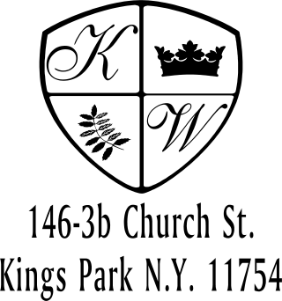 Kings Wood Owners’ Corp.
_______________________________________________________________________________________________________________
146 Church Street, Apt. 3B (631) 269-6424 Phone
Kings Park, New York 11754 (631) 269-3945 Fax

VEHICLE REGISTRATION FORM

It’s time to update our resident Vehicle Registration records. All resident vehicles must be registered with the Property Manager and have a parking sticker affixed to the rear window.

Please complete this form and let us know if you need a KWOC parking sticker. Also attach the following and return them to the Property Office as soon as possible:
- Copy of your driver’s license
- Vehicle insurance registration
----------------------------------------------------------------------------------------------------

DATE: _______________

RESIDENT NAME: _________________________

SHAREHOLDER:_________________ _____Need KWOC Parking Sticker

UNIT #_________ RESERVES SPOT #______________

MAKE:____________________ MODEL______________________

COLOR____________________ LICENSE PLATE #___________________

RESIDENT NAME: _________________________________

SHAREHOLDER:_________________ _____Need KWOC Parking Sticker

UNIT #_________ RESERVES SPOT #___________

MAKE:____________________ MODEL______________________

COLOR____________________ LICENSE #____________________

