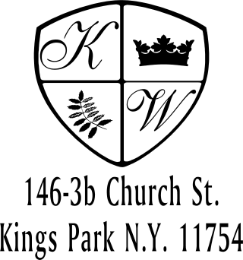 Kings Wood Owners’ Corp.
____________________________________________________________________________________________________________________
146 Church Street, Apt. 3B (631) 269-6424
Kings Park, New York 11754 (631) 269-3945 Fax

TO: The Board of Directors DATE: ____________________
RE: Request for Installation/Renovation

NAME: __________________________________________ APT#_______________

CONTRACTOR(S): ____________________________________________________________

The following is a description of my proposed installations/renovations: ___________________

______________________________________________________________________________

Please check off all new materials to be installed: *NOTE: FULL TILE/GRANITE WALLS AND CEILING NOT PERMITTED

Tile _____________________ (linoleum, porcelain, ceramic)
Granite/Marble _____________________ (countertop, backsplash, floor, bathroom walls)
Mud Floor _____________________ (or wonder/cement board) recommended to remove all old flooring, exposing subfloor plywood

New Tub Material _____________________ (no cast iron, jet, or soaker tubs permitted
TUB DRAIN MUST BE BRASS)

New Toilet ____________________ Deep Wax Seal (thicker to prevent future leaks)

Shower Body __________________ (replace with Temp Pressure Balancing

Rough-In Valve (With Valve Stops)

Shower Pan (waterproof)___________________ For shower stalls in place of a tub

Vanity/Toilet/Kitchen Valves _____________________ Install Apt Isolation Valve “Gerber” or “Central Brass” (Hot & Cold/ea Tile Stop)
Air Arester 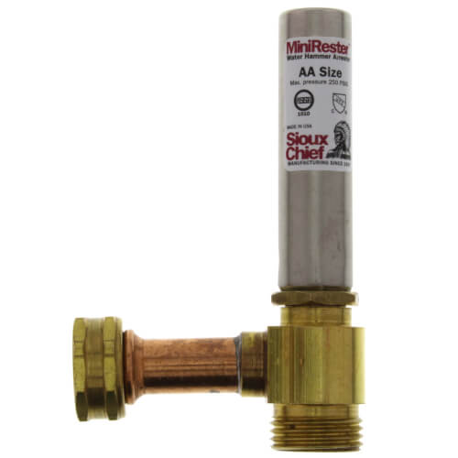 _____________________ Install with New Plumbing
Appliances _____________________ (no commercial 6 burner stoves permitted)
Refrigerator _____________________ (size & weight, NO ICE MAKER)
Air Conditioner _____Current Sleeve _____New Sleeve (size/weight)
Demolition _______________________4”x4” Lead Test (demo or new electrical
fixtures) All Rotted structure must be brought to Manager’s attention.
Other ________________________________________________________________________

I acknowledge that the Board reserves the right to request a structural engineer.
Attached is a COPY OF THE CONTRACT(S) showing the exact dimensions, materials, and location of the proposed installation/renovation within the apartment.

I agree to provide the Cooperative the following.

1. The enclosed Indemnity Agreement must be signed and returned to the Kings Wood office.

2. Copy of Resident’s Insurance showing a minimum of $100,000 general aggregate per occurrence showing Kings Wood Owners Corp named additional insured.

3. Contractor's Insurance of $1,000,000 Liability Coverage; Workers Compensation Certificate Coverage not less than $500,000, WRITTEN TO: Kings Wood Owners Corp. 146 Church Street, Apt 3B, Kings Park, NY 11754, its Board of Directors, and trustees, and employees as an additional insured, no more than 30 days old.

4. Copy of Contractors License.

In the event that my contractor does any damage to the common properties as determined by the Board of Directors, I assume full responsibility and agree to indemnify the Board of Directors and hold them harmless for any damage or liability.

5. Inform Contractor that workers are not allowed to smoke anywhere on the property.

Very truly yours,

________________________________
Signature

________________________________
Signature

INDEMNIFICATION and HOLD HARMLESS AGREEMENT

This INDEMNITY AGREEMENT (this "Agreement") is made effective as of __________, 20__ by and between Kings Wood Owners Corp. (hereinafter referred to as, "K.W.O.C."), a co-op, having a business address of 146-3B Church Street, Kings Park, New York 11754 and __________________(hereinafter referred to as “contractor”), having a business address of _______________________________ and __________________ and ________________ (hereinafter referred to as “shareholder(s)” ), residing at ______________________________________, New York.

WHEREAS, _______________ (contractor) will be performing the following services for ________________________________ (shareholder(s)): ___________________________________________________________________; and

WHEREAS, in exchange for valuable consideration, contractor and shareholder(s) desire to indemnify K.W.O.C. from any claims and/or litigation arising out of contractor’s performance of the aforementioned work or services.

NOW THEREFORE, in consideration of the mutual covenants and conditions contained herein, K.W.O.C. and contractor and shareholder(s) hereby agree as follows:

TERMS
- Indemnification:
To the fullest extent permitted by law, contractor and shareholder(s), their successors and/ or assigns, jointly and/or severally shall fully defend, indemnify, and hold harmless K.W.O.C.. its officers, directors, shareholders, employees and volunteers from any and all claims, lawsuits, demands, causes of action, liability, loss, damage and/or injury, of any kind whatsoever ( including without limitation all claims for monetary loss, property damage, equitable relief, personal injury, loss of services and/or wrongful death), whether brought by an individual or other entity, or imposed by a court of law or by administrative action of any federal, state, or local governmental body or agency, arising out of, in any way whatsoever, any acts, omissions, negligence, or willful misconduct on the part of contractor, its officers, owners, personnel, employees, agents, contractors, invitees, or volunteers, but not as the result of any act or omission of K.W.O.C., its officers, directors, shareholders, employees and volunteers. This indemnification applies to and includes, without limitation, the payment of all penalties, fines, judgments, awards, decrees, attorneys' fees, and related costs or expenses, and any reimbursements to KWOC for all legal fees, expenses, and costs incurred by it.

- Authority to Enter Agreement:
Each Party warrants that the individuals who have signed this Agreement have the actual legal power, right, and authority to make this Agreement and bind each respective Party.

- Notification of Claims; Litigation:
The parties agree to notify one another in writing to the addresses above of any notice of any claim or service of any litigation papers concerning the work or services mentioned in this agreement or allegedly arising from any act or omission regarding same within ten (10) business days of receipt of the notice or service of documents.

- Amendment; Modification:
No supplement, modification, or amendment of this Agreement shall be binding unless executed in writing and signed by all parties.

- Waiver:
No waiver of any default shall constitute a waiver of any other default or breach, whether of the same or other covenant or condition. No waiver, benefit, privilege, or service voluntarily given or performed by a Party shall give the other Party any contractual right by custom, estoppel, or otherwise.

- Attorneys' Fees and Costs:
If any legal action or other proceeding is brought in connection with this Agreement, the successful or prevailing party shall be entitled to recover reasonable attorneys' fees and other related costs, in addition to any other relief to which that party is entitled.

- Entire Agreement:
This Agreement contains the entire agreement between the Parties related to the matters specified herein, and supersedes any prior oral or written statements or agreements between the Parties related to such matters.

- Enforceability, Severability, and Reformation:
If any provision of this Agreement shall be held to be invalid or unenforceable for any reason, the remaining provisions shall continue to be valid and enforceable. If a court finds that any provision of this Agreement is invalid or unenforceable, but that by limiting such provision it would become valid and enforceable, then such provision shall be deemed to be written, construed, and enforced as so limited. The intent of the parties herein is to provide as broad an indemnification as possible under New York law.

- Applicable Law:
This Agreement shall be governed exclusively by the laws of New York, without regard to conflict of law provisions and any action brought regarding this agreement must be brought in a Court of Competent jurisdiction in Suffolk County, New York.

KINGS WOOD OWNERS CORP.

_____________________________________________________
By: , President / Vice-President

STATE OF NEW YORK)
)ss.:
COUNTY OF )

On the ___ day of __________, 20__ _____________________(KW President/VP) before me personally came to me known, who being by me duly sworn, did depose and say that she is the President/Vice-President of KINGS WOOD OWNERS CORP., the corporation described in and which executed the foregoing instrument; that she knows the seal of said corporation; that the seal affixed to said instrument is such corporate seal; that it was so affixed by order of the Board of Directors of said corporation, and that she signed her name thereto by like Order.
Sworn to before me this

__ day of _________, 20__

NOTARY PUBLIC

STATE OF NEW YORK)
)ss.:
COUNTY OF )

On the day of _______________, 20__ ________________________(name) before me, the undersigned, personally appeared personally known to me or proved to me on the basis of satisfactory evidence to be the individuals whose names are subscribed to the within instrument and acknowledged to me that they executed the same in their capacities and that by their signatures on the instrument, the individuals, or the person upon behalf of which the individuals acted, executed the instrument.

Sworn to before me this

__ day of _________, 20__

NOTARY PUBLIC

__________________________________________
(Name and Title), Contractor

__________________________________________
, Shareholder

__________________________________________
, Shareholder

