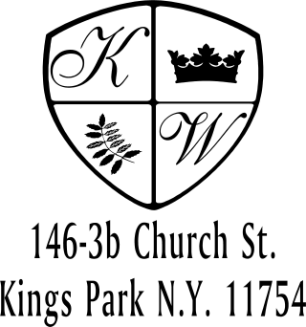 Kings Wood Owners’ Corp.
_______________________________________________________________________________________________________________
146 Church Street, Apt. 3B (631) 269-6424
Kings Park, New York 11754 (631) 269-3945 Fax

TO: THE PROPERTY MANAGER

FROM: APT #__________

DATE: _______________, 20__
Resident Contact Numbers

Please place into the Kings Wood office mailbox at 146-3B.

Thank you for your cooperation.

----------------------------------------------------------------------------------------------------------------------

Apt. #__________ Reserved Parking Stall #____________

Resident Name________________________________ E-Mail __________________________

Resident Name________________________________ E-Mail __________________________

Home_____________________ Work_____________________ Cell_____________________

Primary Emergency Message Phone #_____________________

Emergency Contact Name ________________________________

Home_____________________ Work_____________________ Cell_____________________

Other________________________________________________

